Question 4

First we are checking users

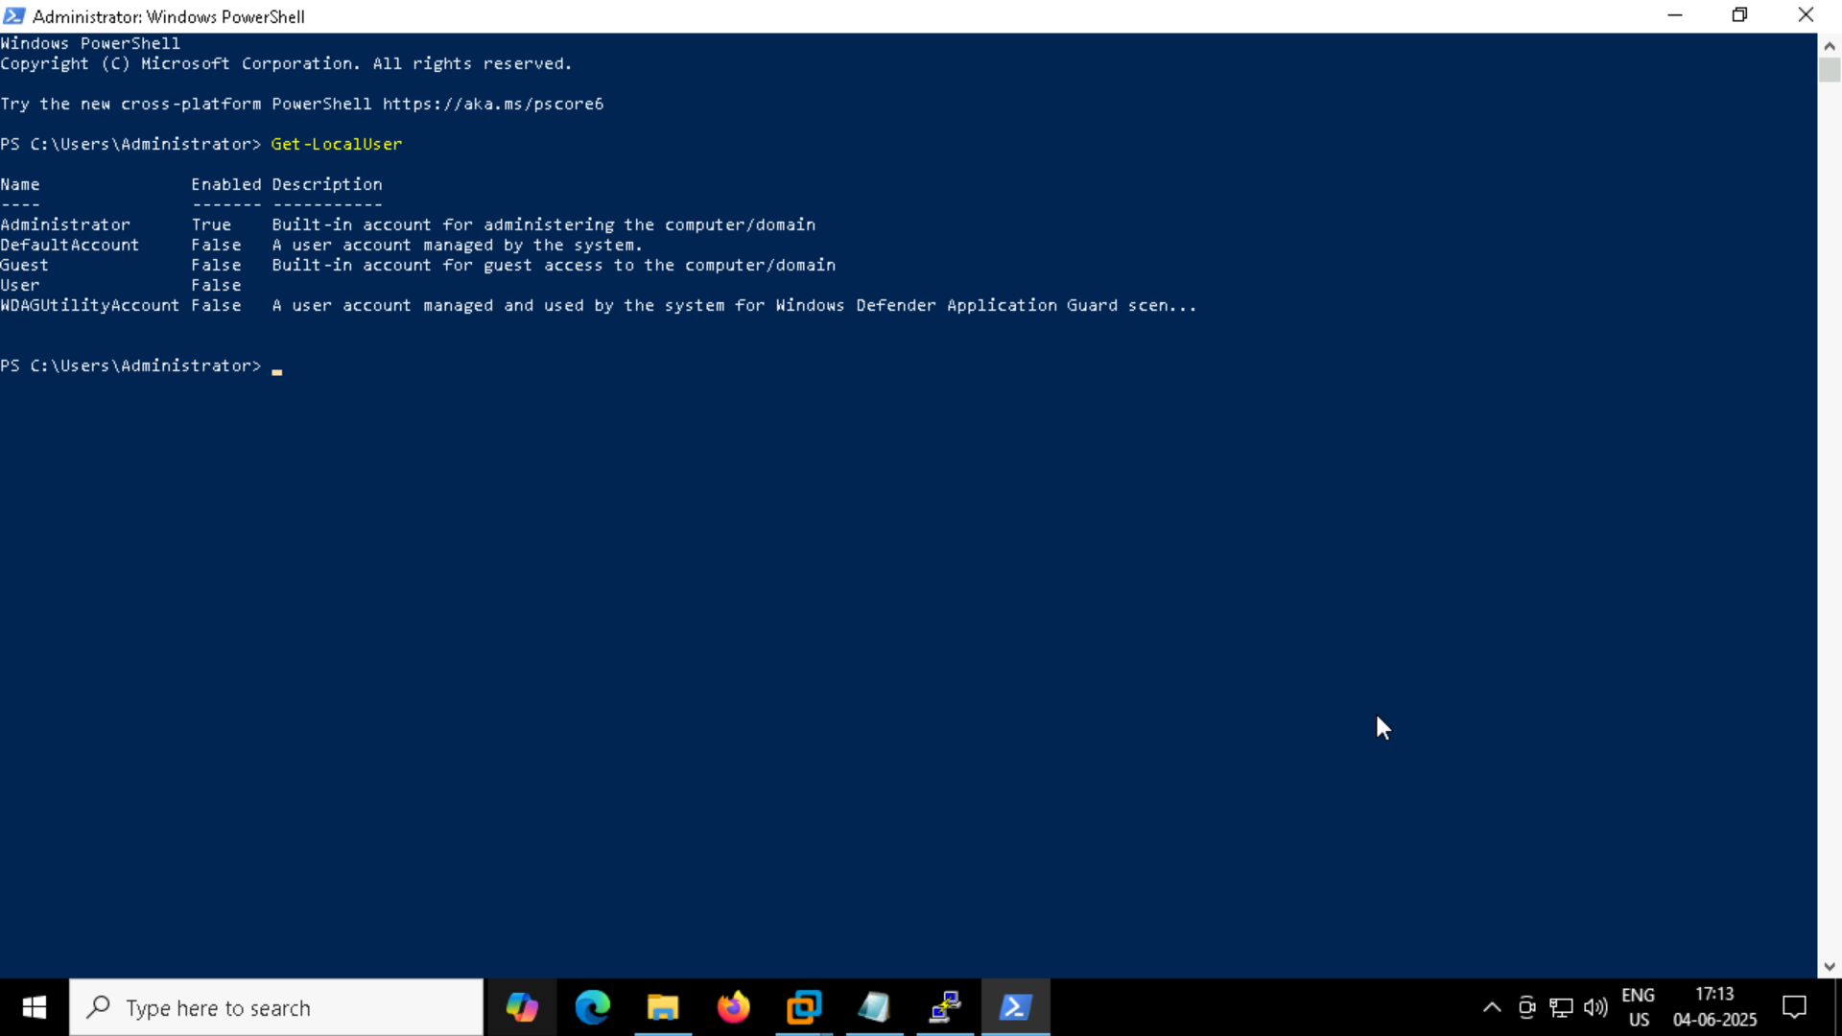

Now we can see the state of the user like enabled or not for example the administrator is enabled so it is true

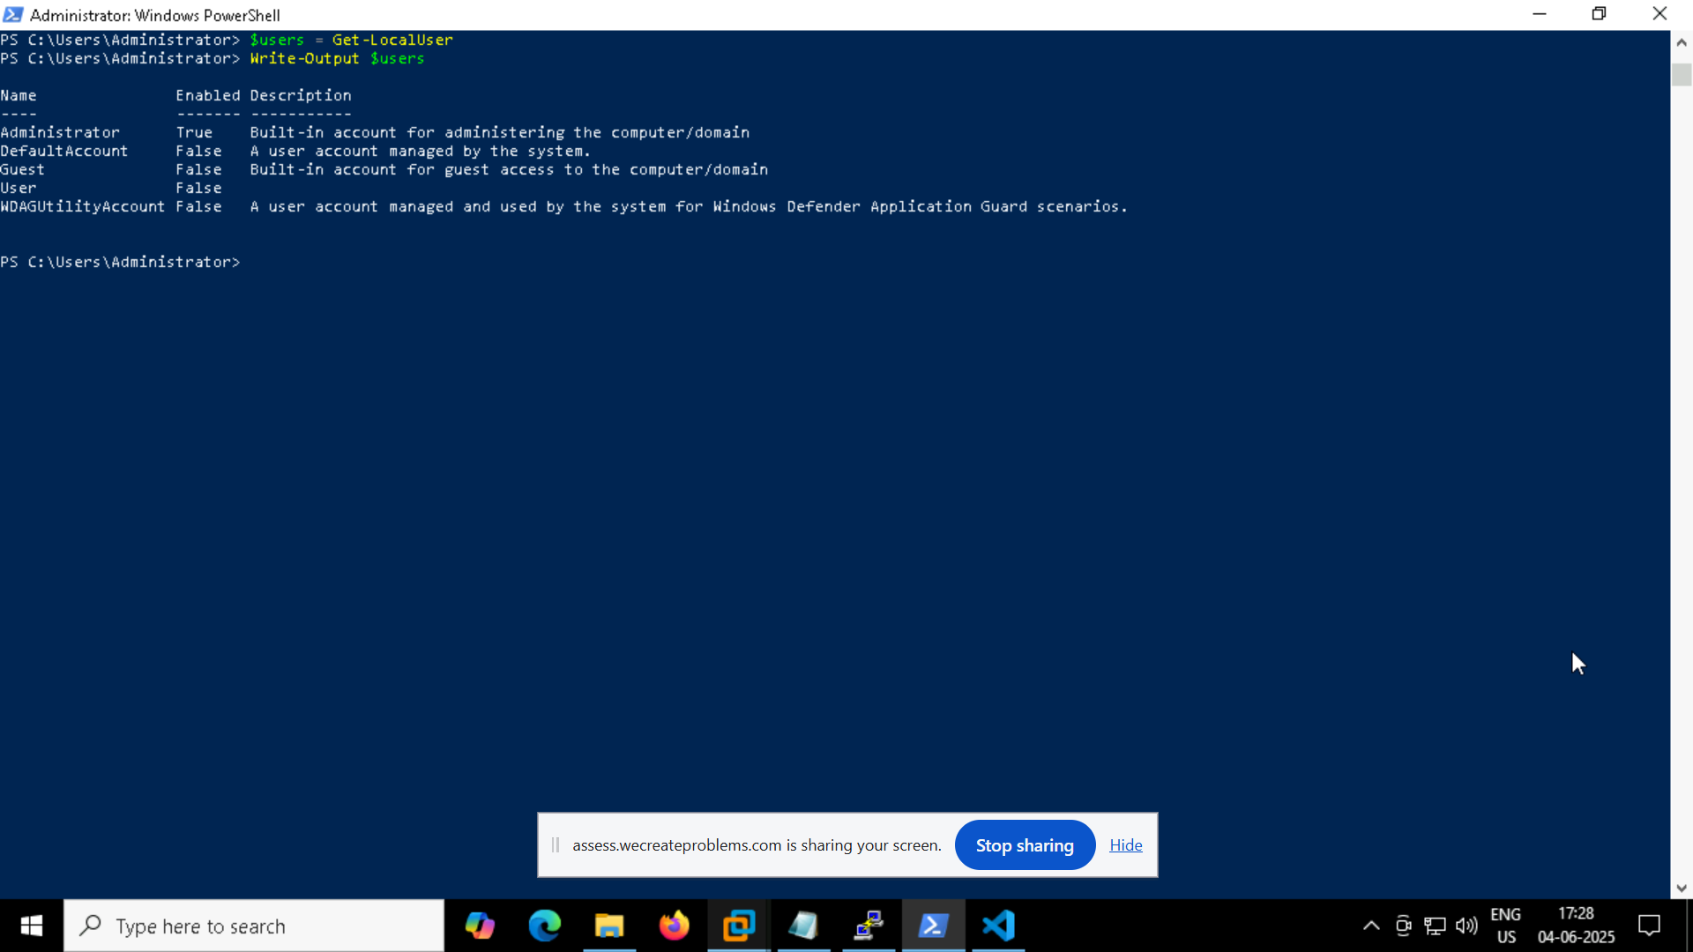

Copying the users to the bhargav.csv file

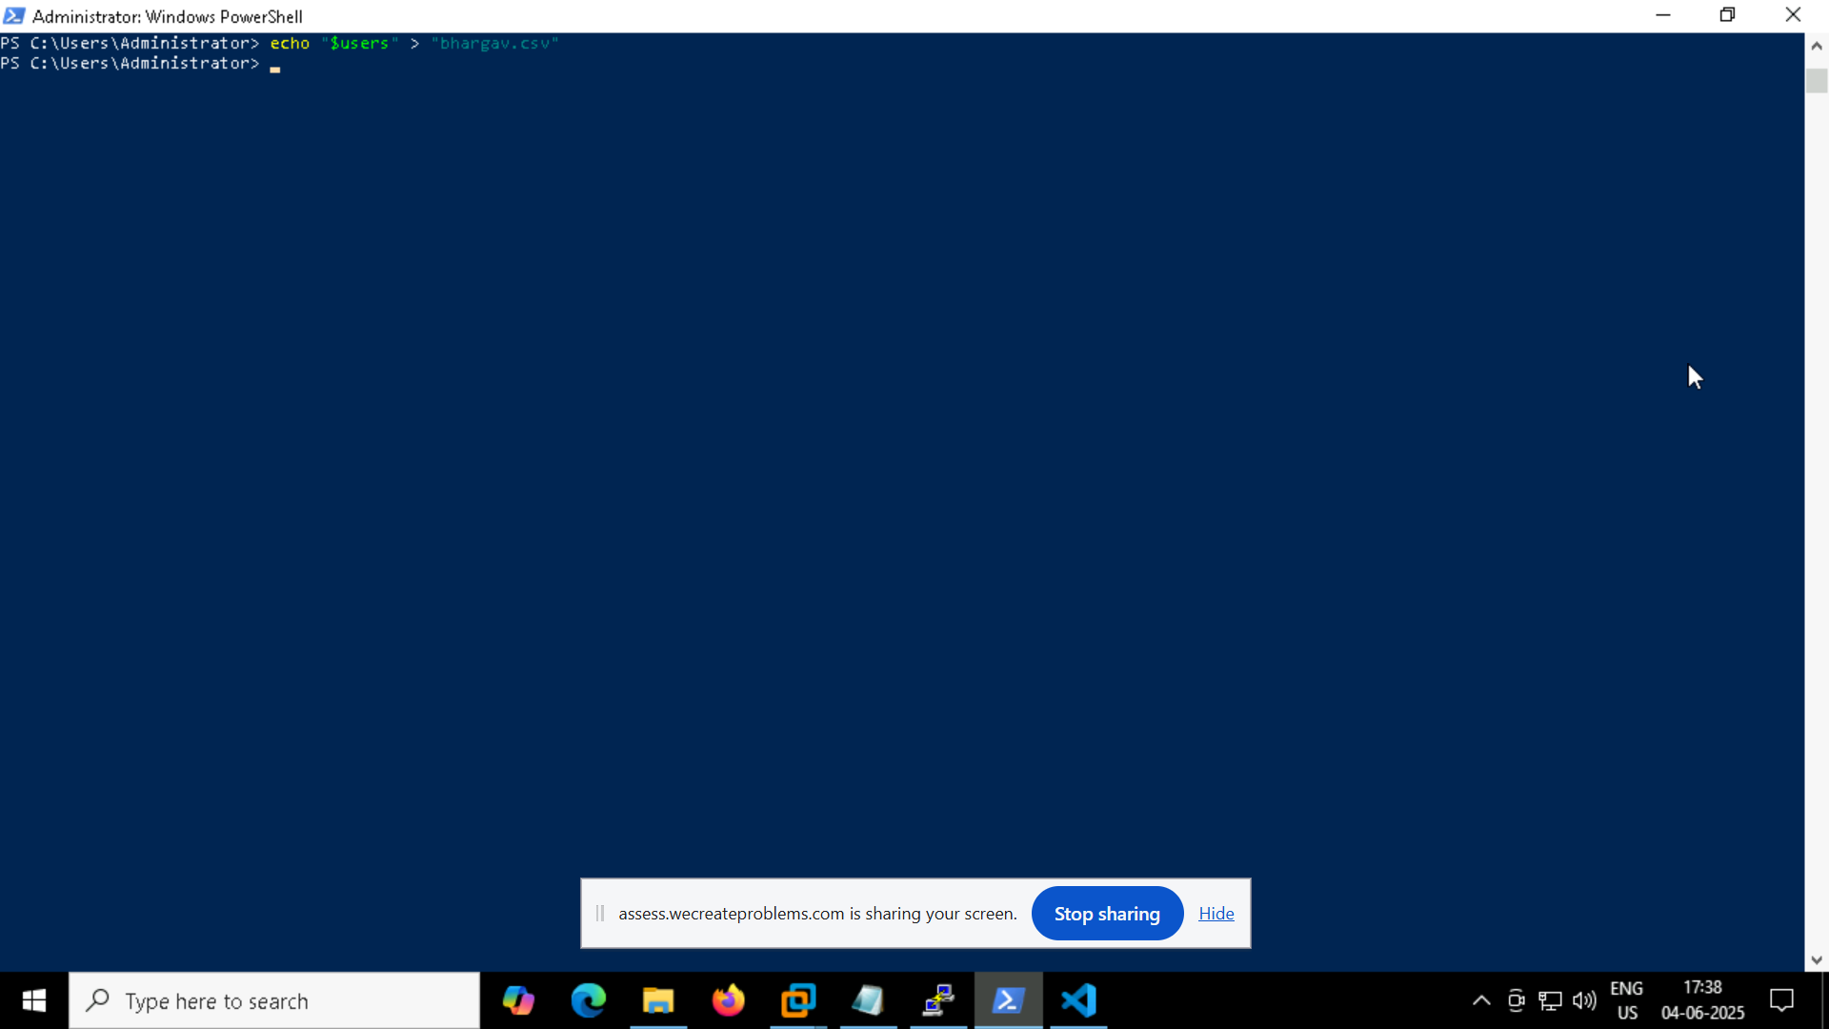

So the administrator Default Account is stored in it

